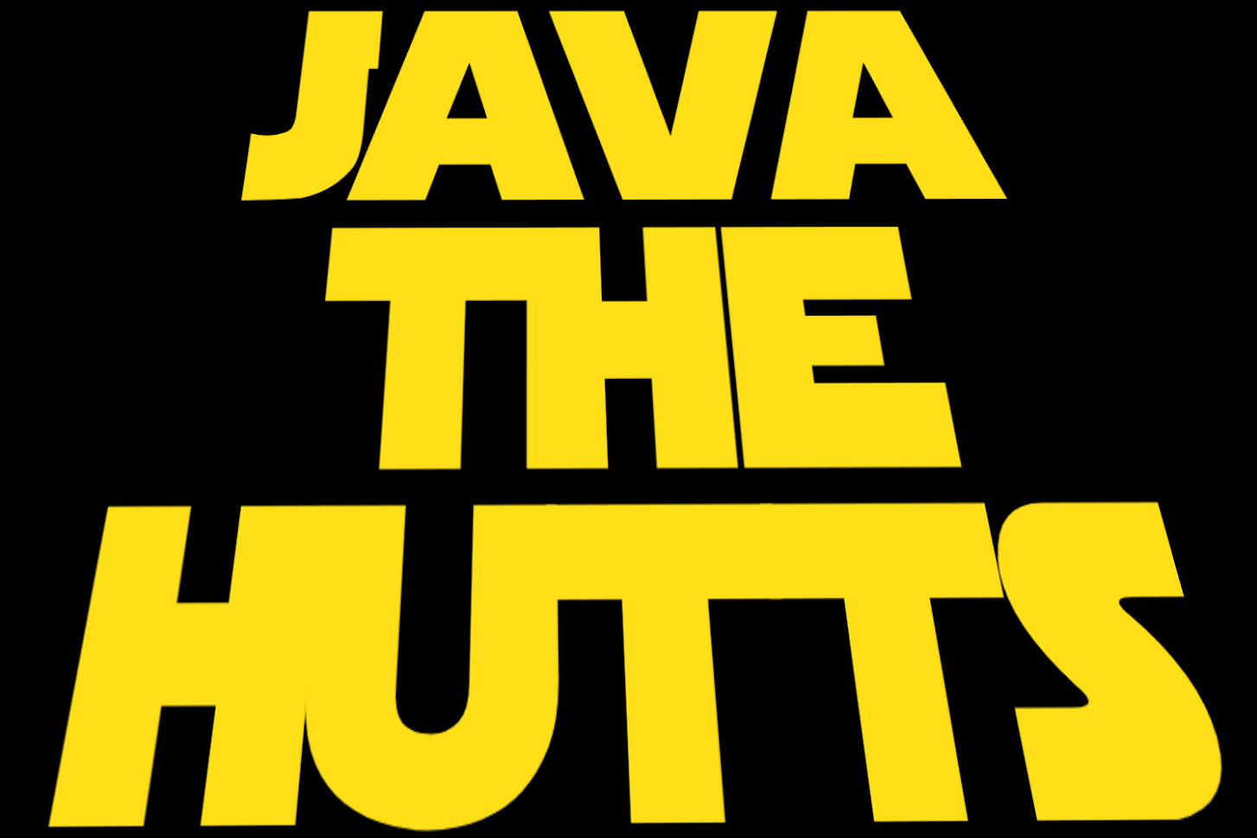

Team #14725

**Table of Contents**

**Page**

**Getting to Know the Hutts**

Team Summary Page………………………………………………………………2

Member Introductions………………………………………………………3

**Expenses**………………………………………………………………………………………………8

**Goals**………………………………………………………………………………………………………12

**Weekly Achievements**…………………………………………………………………13

**How the Robot Works………………………………………………………………**…36

Controls

**Coding the Robot………………………………………………………………………**…40

The Beginning

The Telemetry

Mecanum Wheels

|  |
| --- |
| **Team Summary Page** |

|  |
| --- |
| Our team, Java The Hutts, is based in Fort Myers, Florida. Because we’re the first FTC team in our county, our goal is to spread the awareness of robotics and get more and more students involved with FIRST. We have already inspired 4 other teams in our county to join as a result of our incredible finish last year - 4th in the state and 64th in the nation. We were a rookie team last year, and encountered a vast set of challenges, ranging from how to code our robot to what would be the best design for our robot. Now that we have a better understanding of everything and have learned from our mistakes, we believe the team can triumph in First and come in first. Here is the team. |

|  |
| --- |
| **Our Team** |
| **Max Bazan:** |
| Maz Bazan attends CanteburySaint Michael’s and is in the 98th grade. He is not only talented in stem related activities but also does sports such as soccer and football. |

|  |
| --- |
| **Aum Dhruv:** |
| Aum Dhruv attends Fort Myers High School Paul Laurence Dunbar Middleand is currently in the 98th grade. If he had to choose one stem related activity he likes, it would be math. His special interests also include being the co-captain of the math team and swimming. He is additionally our coach. |

|  |
| --- |
| **Nicholas Harty:** |
| Nicholas Harty, attendsFort Myers High School Paul Laurence Dunbar Middleand is in 98th Grade. His strong suits are in stem-related subjects such as math, science, and technology. His special interests include mathematics,as leader of the Dunbar Math Team, soccer, and coding in his spare time. |

|  |
| --- |
| **Cayden Keene:** |
| Cayden Keene currently attendsFort Myers High School Paul Laurence Dunbar Middle and is in the 98th grade. His special interests include math, science, and coding. His achievements include being a part of the 1st place stem team, and placing in the Kiwanis Regional Science Fair. |

|  |
| --- |
| **Ishaan Ahmad:** |
| Ishaan Ahmad is currently in Canterbury School of Fort Myers and is in the 8th grade. His special interests are in mathematics, soccer, and playing in the band. His achievements include being a part of the winning stem team of Southwest Florida. |

|  |
| --- |
| **Net Outflow** |
|  |
| This is a chart representing what percent of our budget is spent on what. |

|  |
| --- |
| **Net Inflow** |
|  |
| This is what the budget is comprised of and where the money in the budget came from. |

|  |
| --- |
| **Net Outflow** |
|  |
| This is what the expenses are comprised of and where the money in the budget is spent. |

|  |
| --- |
| **Accounts** |
|  |
| This shows the amount of money we have in each of our accounts. |

|  |
| --- |
| **Goals** |
| Our goals for the season are to do the best we can as a rookie team while working together efficiently. |
|  |
| Since we are a rookie team, we want to show others that even though we lack experience, we make up with our dedication and persistence. |

|  |
| --- |
| October 7th: |
|  |
| Today marks the beginning of the construction of our chassis. After we got our shipment of mecanum wheels, them up to our frame. This will allow us to move across the crater freely. |

|  |
| --- |
| September 23rd |
|  |
| We were brainstorming the design for our chassis to see which design would be best to use. |

|  |
| --- |
| September 23rd |
|  |
| Today we are researching the most effective ways to extend an arm and collect materials. We decided upon using a linear slide as the arm. |

|  |
| --- |
| October 11th |
|  |
| Today was our presentation to Southwest Florida Regional Technology Partnership. This presentation was geared to spread knowledge of FIRST to the owners of technology companies and a way to get our name out there for possible donations. |

|  |
| --- |
| October 11th |
|  |
| This is our field demonstration to show everyone what our robot is capable of doing. During this we explained the mechanics of our robot and what everything does. |

|  |
| --- |
| November 1st |
|  |
| In this picture, our java programmers were working on the code of the mecanum drive. This is the basics of moving the robot forward and backward and strafing right and left. |

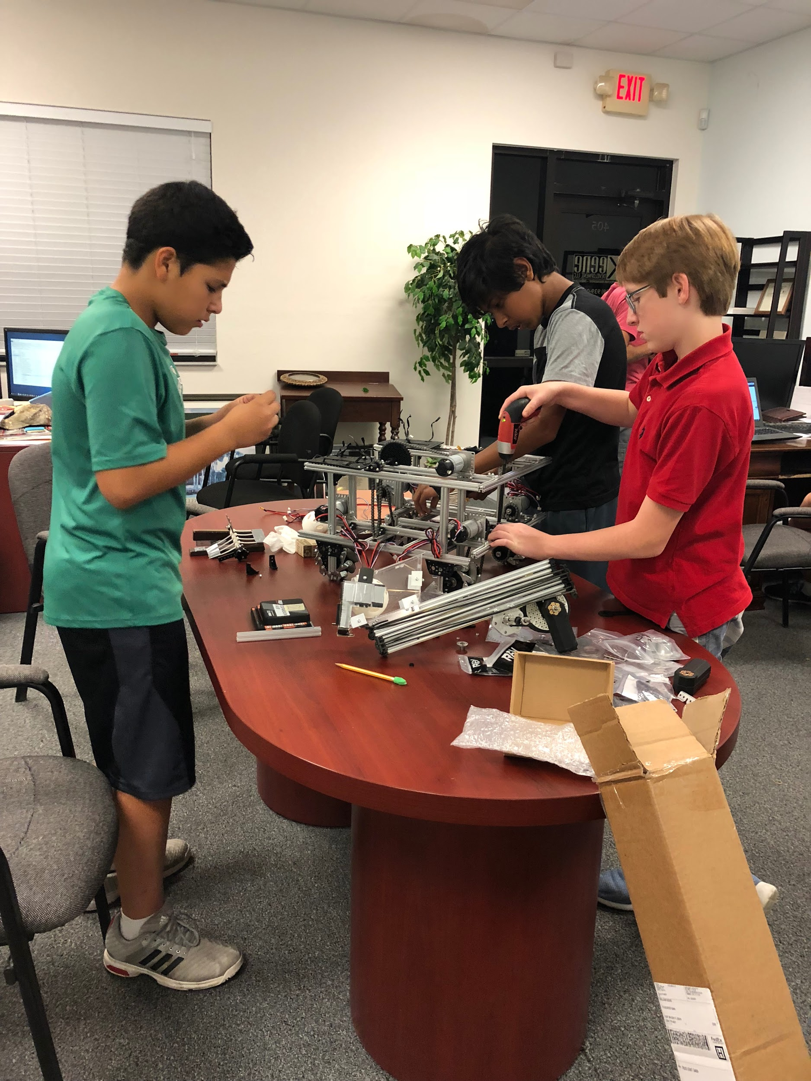

|  |
| --- |
| November 6th |
|  |
| Today was the prototype for our hook but unfortunately, we encountered a problem because when you latch on the hook bends. |

|  |
| --- |
| November 10th - First Meet |
|  |
| One of the main things that we learned in this meet was what needed work on and what we performed well in. During this meet, we came in 2nd place and had the highest scoring with a score of 235! We thought that the thing which needed most work on was the collection system so we went to work on that as soon as we got to practice. We updated the collection system from a jaw to a rotary collector which spins the balls into the box. Our team quickly realized that something which would gain us a lot of points was the mineral detection program so that was also a priority made by us. |

|  |
| --- |
| November 18th |
|  |
| Today we worked on the construction of the collection box and decided that our final design would be something similar to the one shown in this picture. |

Engineering Section

Week 1: Today we are in the process of assembling the lander, this will enable us to test our robot’s functionality in the future.

Week 2: We received the parts for the chassis and coded a simple moving right and left function. After testing, we have come to the conclusion that mecanum wheels would be more efficient in getting over the crater.

Week 3: We were looking for grants to help fund the parts to construct our robot while exploring ways to add on to the code.

Week 4: We went to a local company, Blue Sparq, which opened our eyes to the applications of code in our day to day society.

Week 5: We recruited two new additions to our FTC team. We believe that their strengths will bring a new set of skills to compliment upon the rest of the team.

Week 6: We completed the assembly of the lander and started brainstorming the different designs of the arm that will be collecting minerals. Our programmers finished the mecanum drive code.

Week 7: We decided upon the design mechanism of the arm. Our final decision was that the linear slide would be most beneficial to our alliance.

Week 8: We presented our robotics team to an organization in order to procure sponsors and get funding for our robot.

Week 9: We are preparing and putting the finishing touches on our robot for the upcoming FTC scrimmage.

**First Scrimmage:** During this scrimmage, we got a good look at how the other teams went about their design for the robot and how we could improve. Our coders also further advanced the code by adding an autonomous period which will get us a higher score in competitions.

Week 10: We had returned from the scrimmage and gathered information on how other teams had decided to construct their robot.

Week 11: We are brainstorming the different designs of the box which will enable us to collect materials more efficiently and worked on coding to make the arm move .smoother. We also finished attaching the vertical lift.

Week 12: The assembly on the robot is almost completed for the first meet. We attached the battery and the phones using a bent acrylic. We bent the acrylic using a heat gun so it was more flexible, then we shaped it and let it cool and harden. The programmers coded the lift to hold the robot and they also reviewed existing code to ensure it was working. We made a new, strengthened hook and are finishing the construction of the box.

**Meet #1:** We were challenged with the task of communicating with our alliance members and talking out a strategy to gain the most points. At the end of the meet, we had the highest score with a score of 235 points. As a rookie team, we placed second out of sixteen teams.

Week 13: We brainstormed ideas on how to improve the collecting box of our robot. We decided upon removing the jaw and replacing it with a rotary collector which spins and pulls the ball into the box. We ordered parts for a new linear slide and was thinking about potentially adding a second linear slide. To have the new collector, we changed the servo to continuous so it will pull minerals in more efficiently. We swapped out the servo with a core hex motor to improve the strength, power, and the durability of the end of the arm. This will improve the precision and ability of our team while we try to collect minerals.

Week 14: We decided upon not getting a second linear slide and focus on the one that we have. We built the new linear slider which is sturdier and is more powerful which will help controlling the arm. We also started to look into ideas to incorporating a camera onto our robot to help detect the minerals in autonomous mode.

Week 15: Thanksgiving Break.

Week 16: Something beneficial about the new linear slide is that is that when it goes back it does not succumb to the force of gravity and come down. As we finish up the new rotary collector, our programmers are figuring out how to.

**Cypress Lake Middle Demo 12/08/2018:** Today we travelled to a local FLL competition to show younger people what the next step in FIRST looks like. We were subjected to a stress test when we let the younger people test our robot. As you know, with actions comes consequences. As a result of letting the younger people test, our vertical lift chain fell off and our linear slide snapped. We replaced the plastic parts that had broken off when one of the kids slammed the robots arm into the ground, and we put the chain back in place.

|  |
| --- |
| December 18th |
|  |
|  |
| These are some of the students that were competing at the FLL meet. We decided to further show our robot off by letting some of the kids drive it around on the ground and explaining to them how to operate the controls. |

|  |
| --- |
|  |
| We were handing out these customised cookies, that have our team logo on them, out on the FLL meet. |

|  |
| --- |
| Week 17: Our objective of this meeting was to fix the problems which occurred at Cypress Lake, like adjusting our autonomous code so we get more points during matches, and replacing a few of our robot’s parts that weren’t performing very well. |
|  |

|  |
| --- |
| Week 18: We worked on coding our autonomous for the next meet at Boca Ciega High School and we practiced driving the robot so we would perform well at the meet. Those of us who were not coding focused on improving upon our engineer notebook |
|  |
| so that we would not only do well in meets, but also our notebook. |

|  |
| --- |
|  |
| Week 19: We went to the Meet at Boca Ciega High School on December 15th. We came in fourth and the second place team chose us to be their teammates in the fast finals. The fast finals is where the top two teams each pick another team from the meet to be their alliance partner. |

|  |
| --- |
| December 15th |
|  |
| In the stressing fast finals of the second meet, after winning our first match out of 3, our second match was so close that we lost by 1 point! |

|  |
| --- |
| December 15th |
|  |
| Proud teammates setting our robot down during the second meet. |

|  |
| --- |
| December 15th |
|  |
| This is when we were testing our autonomous during the morning of the second meet. |

|  |
| --- |
| December 15th |
|  |
| This is a picture of us trying to fix the errors in our autonomous portion of the code. |

Week 20: We finalized the problems that we had at the competition and started to solve some of them. Because we are a rookie team, we don’t have mentors with FTC experience, so we learn with every FTC meet.

Week 21: We replaced our worm gear because it was becoming useless and the arm would still move to much. We replaced the plastic gears on our wheels with metal ones so that they wouldn’t flex under pressure. But since the metal gears had different ratios we had to change the code so that the wheels wouldn’t spin too fast. Then we worked on our autonomous code so that we would be ready for our meet on Saturday, and practiced driving the robot so we would be more experienced and more familiar with the controls.

**How the Robot Works**

**Driving Controls:**

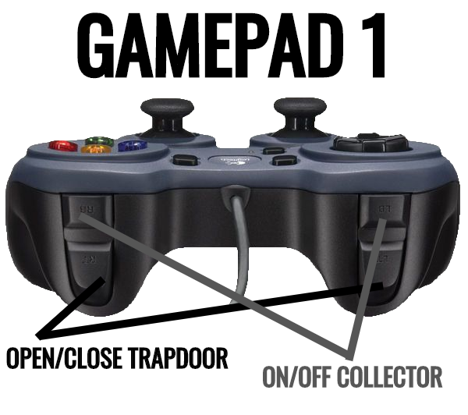

**Driving the Arm Controls:**

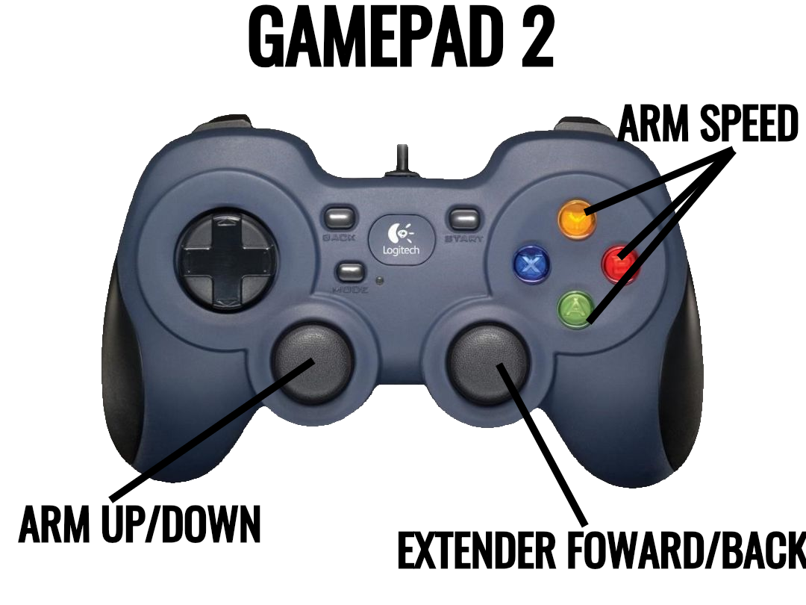

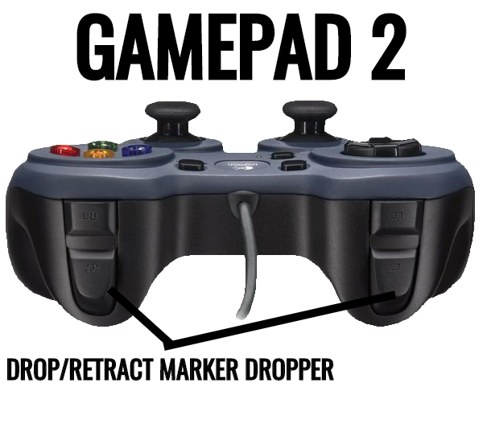

**Coding The Robot:**

**The Beginning:**

|  |
| --- |
|  |
| We started off this season with very little coding knowledge at all. At the beginning, we referenced the FTC Forums a lot. We started off coding basic TeleOP code on the OnBot Java Compiler. |

**The Telemetry:**

|  |
| --- |
|  |
| Then, once we became more advanced, we started coding custom telemetry (what the output is on the phone) so we could tell what port each servo and dc motor is plugged into. |

**Mecanum Wheel Code:**

|  |
| --- |
|  |
| Early on, we made the decision to use mecanum wheels because of their ability to strafe, and go at diagonals. The code was very hard to comprehend at such an early stage of interest in this subject. |